**PanGIA GUI Manual:**

Guide to preparing the PanGIA GUI

**Table of Contents**

1. Introduction

2. Initial Download Instructions

*2.1*: PanGIA & GUI

*2.1.1*: Gitlab Pull

*2.1.2*: Manual Download

3. Preparing Compute Environment

4. Using the GUI

*4.1*: GUI Access:

*4.2:* GUI Navigation

*4.2.1*: Dashboard

*4.2.2*: Users

*4.2.3*: Settings

*4.2.4*: Projects

*4.2.5*: PanGIA/PanGIA Results

*4.2.6*: Real Time

*4.3*: Running PanGIA: Examples of Usage

*4.3.1*: Example #1: Static Case with ANNOY analysis

*4.3.2*: Example #2: Real-Time Case with T-MARK analysis

*4.3.3*: One with Decision Tree

5. GUI Visualizer: Current Capabilities and Future Improvements

Section 1):**Introduction:**

This report contains instructions for the installation and use of the graphical interface designed for PanGIA. PanGIA is standalone and may be run independently from the command line. However, this forces the responsibilities of manual configuration and record keeping for each run entirely onto the user.

This GUI companion to PanGIA makes the pathway to discovery more efficient and exciting by streamlining the run specification/execution process, providing a robust job queue, enabling real-time PanGIA processing, and constructing an intuitive, informative, dynamic visualization tool for result analysis. The GUI is composed of six parent pages: *Dashboard*, *Users*, *Settings*, *Projects*, *PanGIA*, and *Real Time*. If you have already completed PanGIA setup and are using this document as a GUI reference, please consult **Section 4.2** onward.

**Section 2):** **Initial Download:**

This section details the process of downloading PanGIA, the GUI, and curated reference databases necessary to run PanGIA.

**2.1: PanGIA & PanGIA GUI**:

*2.1.1*: *Download from Command Line*:

1. Navigate to preferred local directory.
2. Git clone from <http://gitlab.mriglobal.org/dyarmosh/PanGIA> into the local directory. The command: ‘c**onda install -c anaconda git**’ will install the git package if it is not present.
3. Repeat Step #2 for the PanGIA GUI, but clone from <http://gitlab.mriglobal.org/bclark/pangia-flask-gui> instead. Cloning the repository into a separate local directory is recommended.

*2.1.2*: *Download Manually*:

1. Go to GitLab pages at XXXX (PanGIA) and XXXX (PanGIA GUI).
2. Download both and extract to preferred path for each.

**2.2: Reference Databases**:

Need input from Brian/Joe - not sure how/where these databases will be made accessible.

1. F in chat.

**Section 3): Preparing the Compute Environment:**

PanGIA requires a specific compute environment to satisfy its run-time dependencies. This section covers how PanGIA is constructed locally within a specific Linux distribution.

**3.1: Prepare a Non-Dockerized Environment**:

1. Install Conda and the correct Linux distribution (Ubuntu 20.04.2 LTS).
2. Navigate to PanGIA GUI directory created in **Section 2.1** – use command: ‘**conda env create –f gui.yml’**. This acts on the .yml file within the GUI root directory to construct the environment. By default, name of the environment will be ‘**gui’**,but this can be replaced with any preferred name by renaming the prefix of the .yml file prior to creating the environment.
3. Open a command line window and navigate to the GUI directory. Use command: ‘**conda activate XXX’**, where **XXX** is the name of the environment. Use the following series of commands to finish initial database and environment setup:
   * + **export FLASK_APP=pangia_gui.py**
     + **flask db init**
     + **flask db migrate –m**
     + **flask db upgrade**
     + **conda install -c bioconda fastp**

Whenever accessing the GUI, begin by opening three separate command line terminals, and navigate each into the GUI directory. Next, execute the ‘**conda activate XXX’** command in each of the three separate command line instances/windows. Each instance is responsible for running one of three services comprising the GUI. See **Section 4.1** for more information. The GUI can be completely reset by navigating to http://localhost:5000/auth/reset_site - this is not recommended.

**Section 4):** **Using the GUI:**

Running PanGIA through the GUI assumes that three independent services – a **worker**, **scheduler**, and **Flask server** – are already operational. **Section 4.1** covers the process of bringing each service online and opening the GUI. A complete tour of the GUI can be found in **Section 4.2.** An example of a typical PanGIA runs can be found in **Section 4.3**.

**4.1: Accessing the GUI:**

1. Following instructions listed at the the end of **Section 3.1.3**, prepare three command-line terminals as described.
2. In first window use command: ‘**redis-server**’.

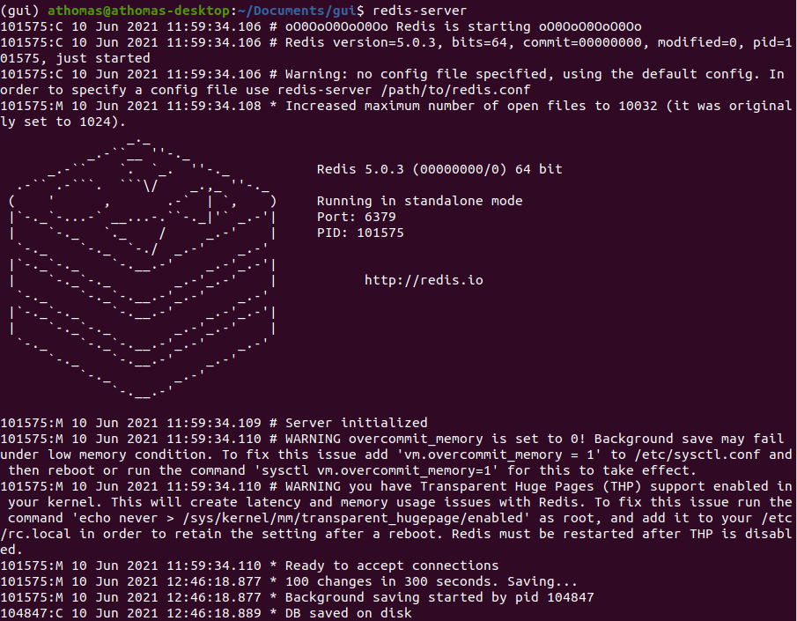

1. In second window use command: ‘**rq worker pangia-tasks**’.

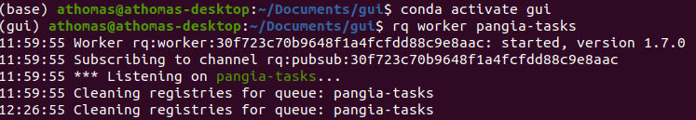

1. In third window use commands: ‘**export FLASK_APP=pangia_gui.py**’ + ‘**flask run**’.

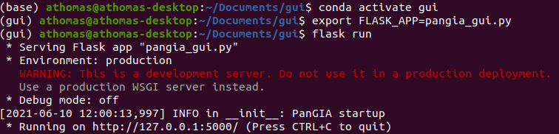

1. In a web browser, navigate to **localhost:5000** for GUI access.

**4.2: GUI Navigation**:

*4.2.1*: *Dashboard*: After logging in, users are directed to this page. It lists the history of both the most recent PanGIA runs and ongoing runs. Links to results and/or the ongoing job status page is provided under each listing. At the very bottom of the page, users may click a link directing to the PanGIA section of the GUI, described in more detail below.

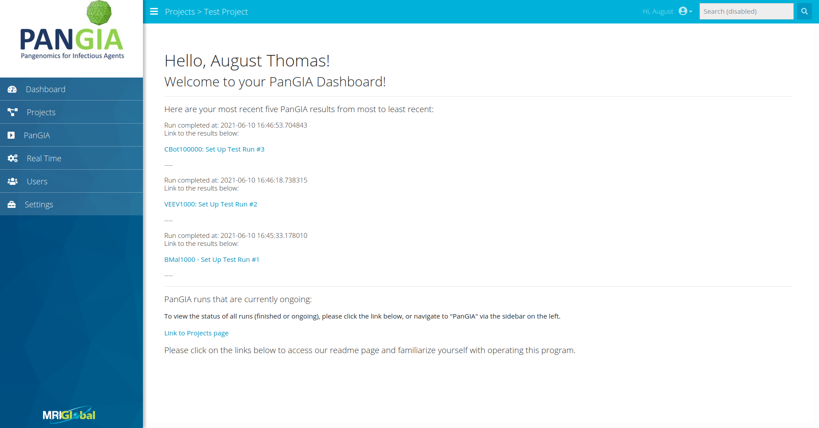

*4.2.2*: *Users*: Interface for adding users to the GUI’s persisted database. Current users are listed with name, username, email, date of last login, and role (Admin, User, etc.)

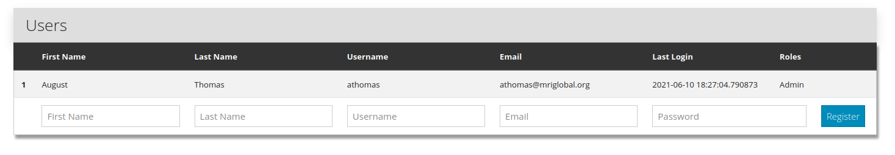

*4.2.3*: *Settings*: Multi-tabbed interface for specification of general settings, PanGIA preprocessing/run parameters, project categories, file templates, and meta-types. Specifics for each tab and sub-tab are listed below.

*4.2.3.1*: **Settings** - **General**: Main options: dedicated to tailoring PanGIA runs to the user’s default needs. Most **General** settings may be adjusted while preparing any PanGIA run but setting default specifications here saves prep-time.

1. *Application Settings*: User specifies PanGIA directory path and PanGIA database/uploads path. Users may adjust thread-count made available for PanGIA. An even number is recommended. Default is two threads.

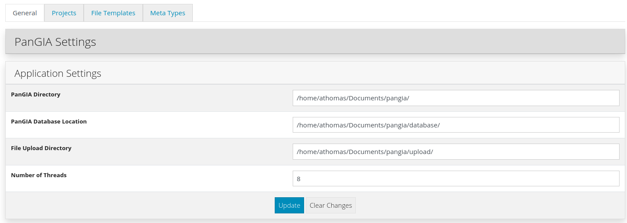

1. *Preprocessing*: Options to alter/filter reads prior to PanGIA analysis. May trim reads for quality level, adjust the average quality, minimum read length, and “N” base cutoff values, apply a low complexity filter, exclude PolyA tails, or indicate a custom number of base pairs to cut from 5’ or 3’ ends of reads. The user may opt to skip preprocessing.

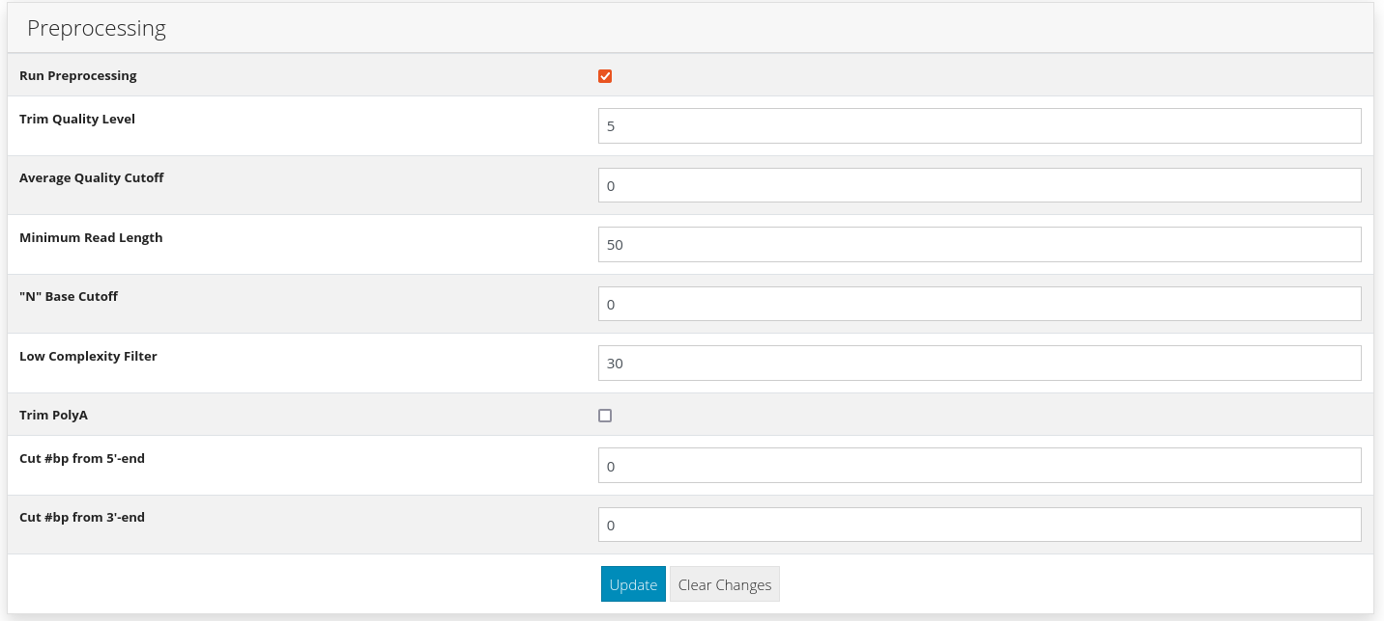

1. *Run Parameters*: Options determining read scoring, and additional forms of analysis (TMARK, Decision Tree, etc.) May specify values for seed length, and assign minimal values for score, aligned score, read count, read RSNB, linear length, percent genome coverage, and depth/RS depth. Scoring method may be selected from a drop-down menu (Standalone/Background/Combined), and a series of check boxes determine if additional analyses are included in the run.

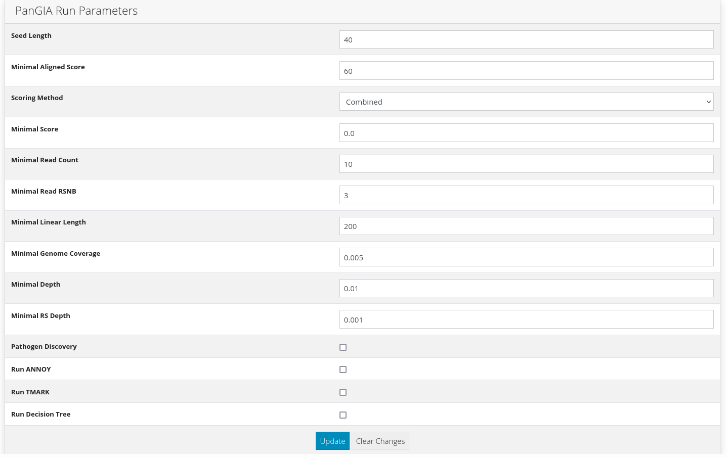

*4.2.3.2*: **Settings** - **Projects**: Used to consolidate and organize related PanGIA uploads/runs. Existing **Projects** may be archived or deleted. **Projects** are instantiated with a name, description, and slug. They may be constructed as children of an existing parent **Project**. When providing a name and slug, use only alphanumeric and ‘_’ characters.

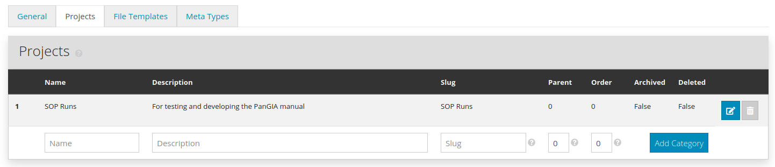

*4.2.3.3*: **Settings** - **File Templates**: User may specify PanGIA input file types other than .fastq on this tab. **File Templates** require a name, description, and file extension. When creating a new **File Template**, the user must decide which **Meta-Types** will be available for runs using that **File Template**. A default for .fastq files is included.

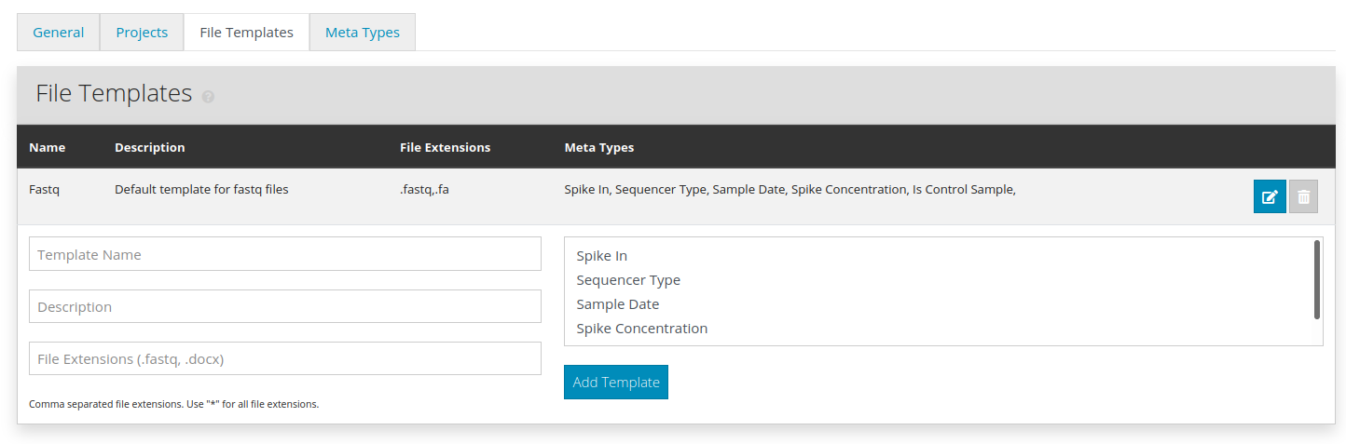

*4.2.3.4*: **Settings** - **Meta-Types**: User may impose additional rules regarding meta-data, grouping it together and limiting input variance. Default **Meta-Types** include names of spiked-in organisms and spike-concentration, sequencing protocol, and the sampling date. User may specify whether data was a control sample. New **Meta-Types** require a name, description, and value (string, integer, Boolean, date, etc.), and may be designated as ‘required’ if desired.

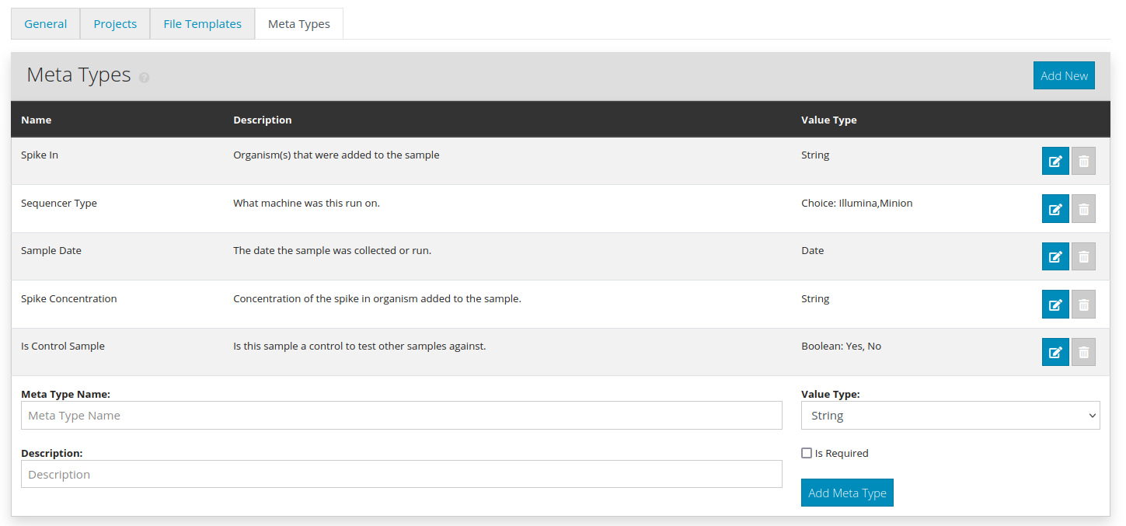

*4.2.4: Projects:* Provides the name of each **Project** constructed in the **Settings - Projects** tab as described above in **Section 4.2.3.2.** Clicking on the name of a **Project** yields a list of all the files that have been uploaded to that **Project**. The list is grouped by **File Template.** Files may be ordered by ascending/descending or date/name. Each **File Template** header has a large blue button labeled ‘**Add New File**’ - this directs the user to the upload interface. Files uploaded through the GUI are copied into a new directory named after the **Project** in the local pangia/upload directory.

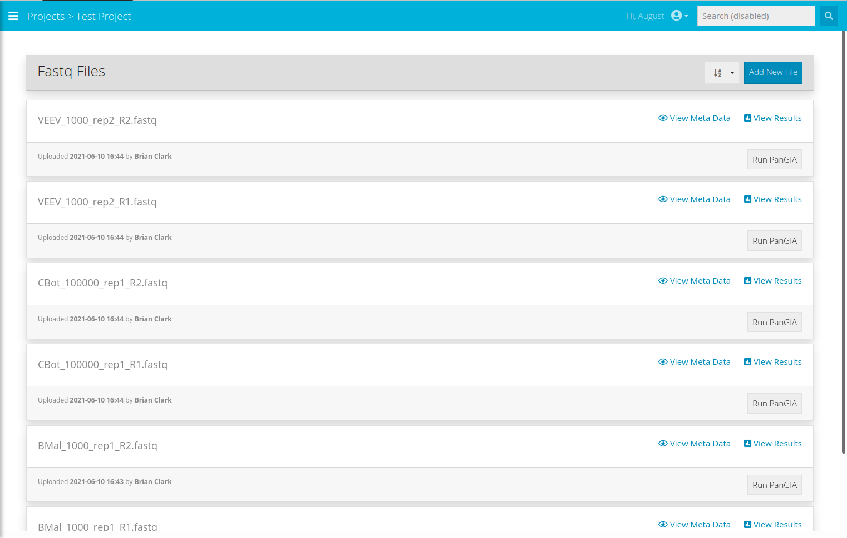

*4.2.4.1*: **Run PanGIA**: To start a job from the **Project** menu, use the ‘**Run PanGIA**’ button on any file uploaded to the **Project**. Each run requires a name and description. Drop-down menus specify which paired files are to be used. The first menu option defaults to whatever file the **Run Information** page was accessed from. All **General** settings may be adjusted here; the interface is identical to that appearing in **Section 4.2.3**.

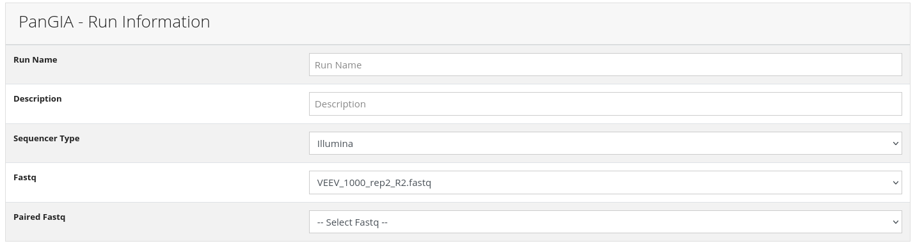

*4.2.4.2*: **Exploring Projects**: Files listed within a **Project** have three interactive links. The **View Meta Data** and **View Results** links direct the user to a new page, with two tabs. These tabs are named **X Information**, where **‘X’** is the **File Template**, and **Results**.

1. The **X Information** tab specifies the filename, upload date, filepath, and description.

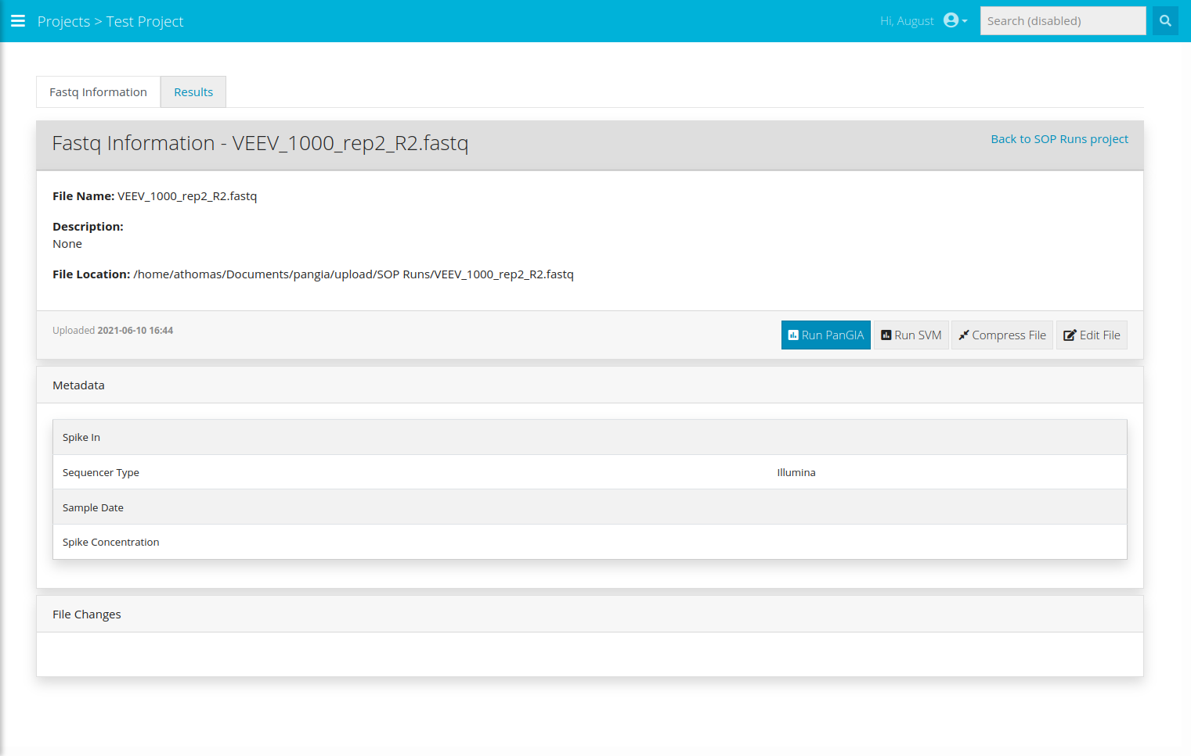

1. The **Results** tab lists all PanGIA runs that the file has been part of. Details include run name/date, description, parent **Project**, user, and filenames.

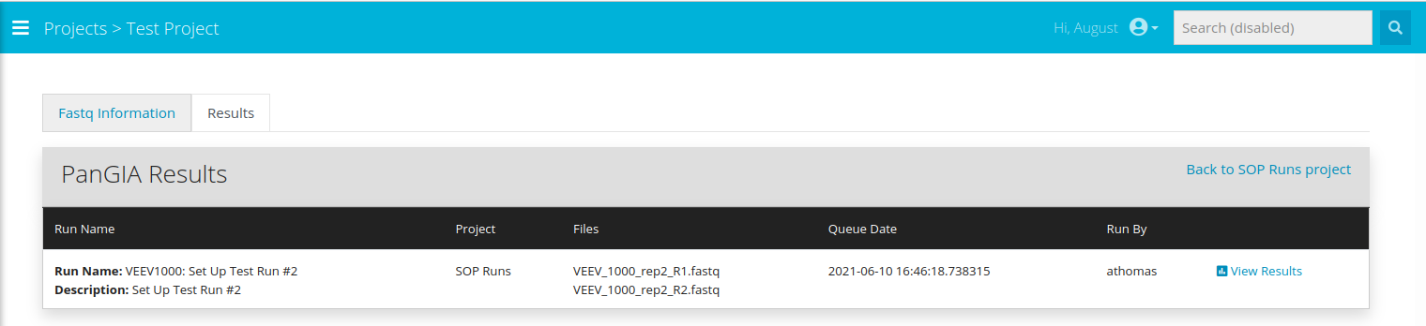

1. Runs have a link labeled ‘**View Results’**. Following this link directs the user to the *PanGIA Results* section of the GUI, described below in **Section 4.2.5.**



*4.2.5: PanGIA/PanGIA Results*: Lists all queued and completed jobs, regardless of **Project**. Each completed job contains the same information found in the **Results** tab accessible through the *Projects* section of the GUI;each job also has the same ‘**View Results**’ link. Both are described above in **Section 4.2.4.**

*4.2.5.1*: **Results Page**: The **Results** page provides run name and description, and features an interactive window to browse rows of the .tsv file output of the PanGIA run. This page also links to the **Visualizer**, which will graphically display that output. An in-depth PanGIA run log is provided at the bottom – the printout there is similar to what can be found in in the **worker** printout during the run. An example **Results** page appears below.

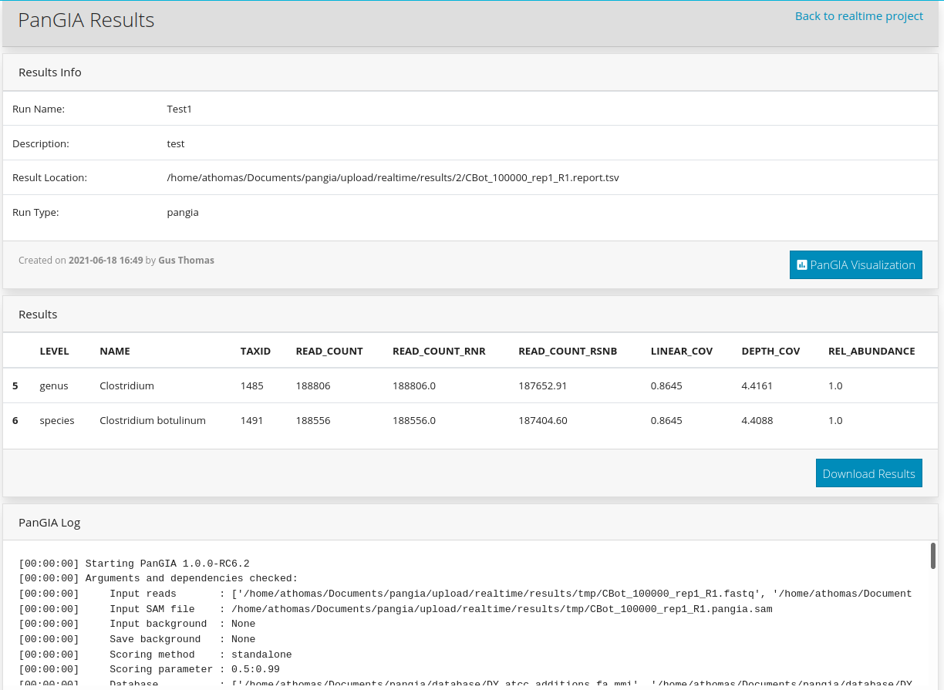

*4.2.6*: *Real-Time PanGIA:* User specifies a job name, description, and associated **Project**, as usual. Instead of paired files, the user must provide the path to a directory that Real-Time PanGIA is listening for. This directory should be the dumping point for ongoing nanopore sequencing. Notably, once Real-Time PanGIA is initiated, the user must manually terminate the job as desired. Completed jobs persist PanGIA results from the last completed job iteration.

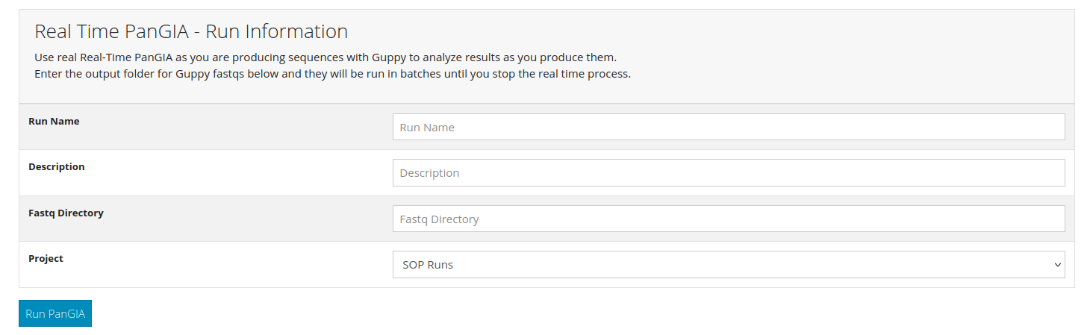

*4.3*: *Running PanGIA: Examples of Usage*:

*4.3.1*: **Baseline Example**: The following walkthrough describes a typical PanGIA run with default settings. For this example, assume the **Project** ‘SOP_Runs’ has already been established, and is accessible through the GUI sidebar as shown below.



This link redirects to the file page associated with ‘SOP_Runs’. For the purposes of this tutorial, assume that two .fastq files – named ‘BMal_100000_rep1_R1’ and ‘BMal_100000_rep1_R2’ – have already been uploaded to the **Project**. The file page for this scenario appears below.

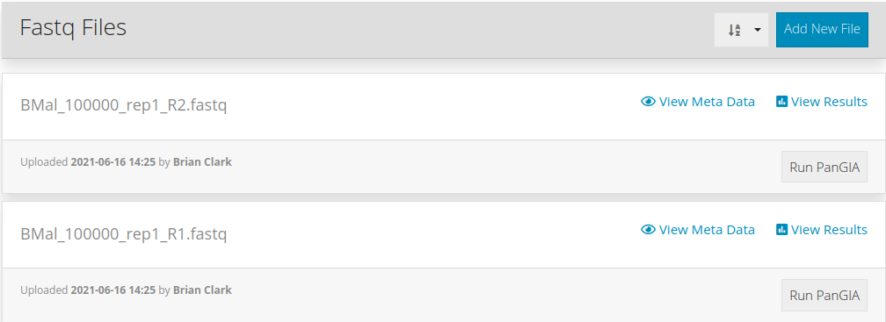Clicking on the **Run PanGIA** buttons associated with either .fastq file directs to the **Run PanGIA** page. As discussed in **Section 4.2.4.1**, this page is split into **Run Information** and **General** settings. Pressing the button associated with ‘BMal_100000_rep1_R1’ directs to the **Run Information page** shown below.

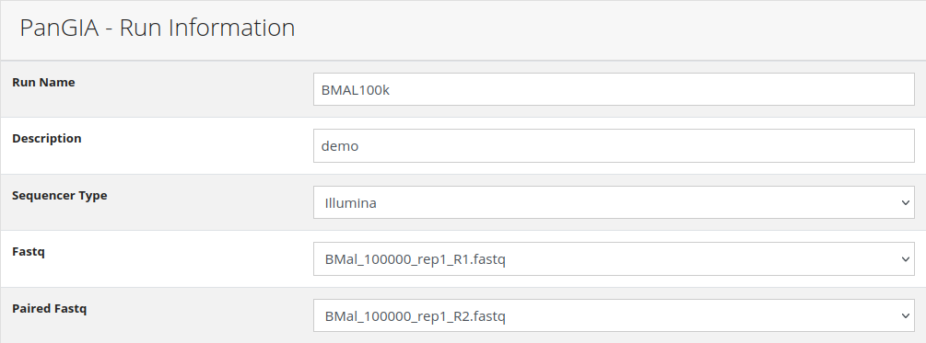This run has been given a name and description, and a selection for the ‘**Paired Fastq**’ has been made – in this case, ‘BMal_100000_rep1_R2’. None of the **General** settings on the **Run PanGIA** page need to be adjusted, as this is a default PanGIA run. This job is ready to be executed by clicking on the **Run PanGIA** button at the bottom of the page.

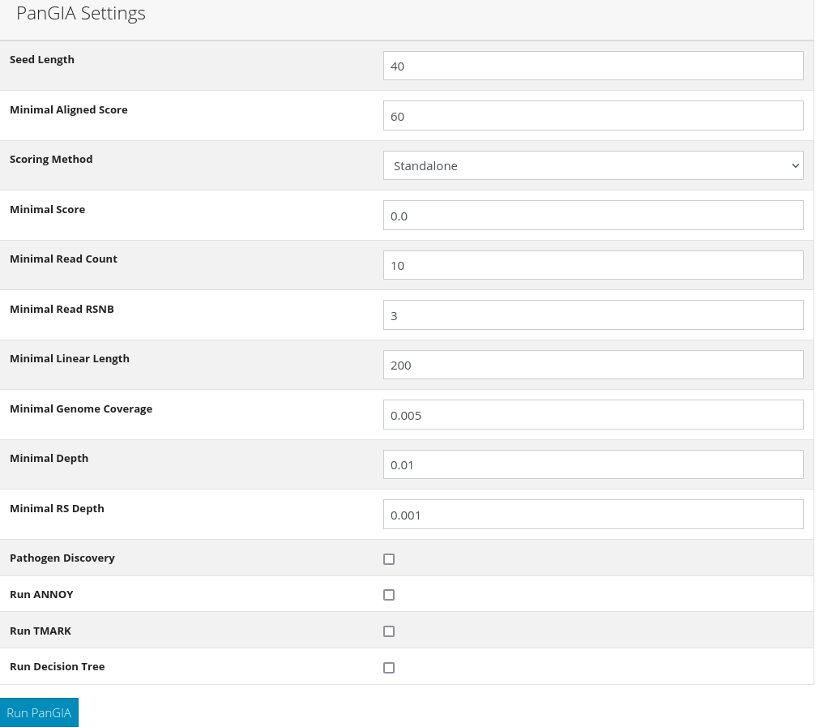

The PanGIA job is now running, which may be verified in a variety of ways. First, navigate to the command line terminal running the **rq worker**. It should look something like this:

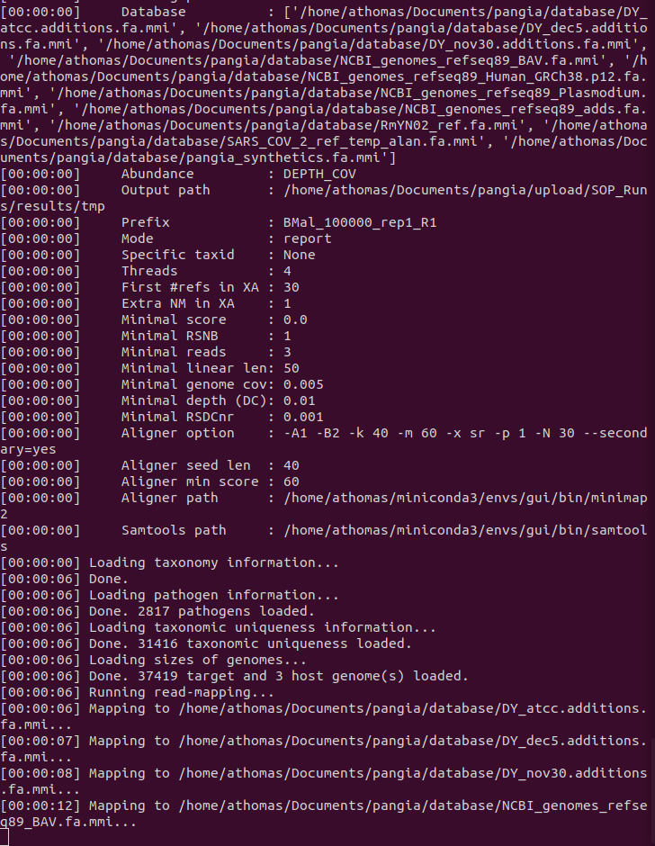

The **rq worker** provides timestamped logs for run status and allows the user to follow along with each compute stage, or troubleshoot. Heading back to the GUI, navigate to the *Dashboard.* It should look something like this:



The current job ‘BMAL100k’ is listed – and the link below the job directs to the **Running Job** page. If additional PanGIA runs were queued behind ‘BMAL100k’, they would also be listed in the *Dashboard* underneath the current job. The **Running Job** page is a run log, and should look similar to the **rq worker** printout, as seen below:

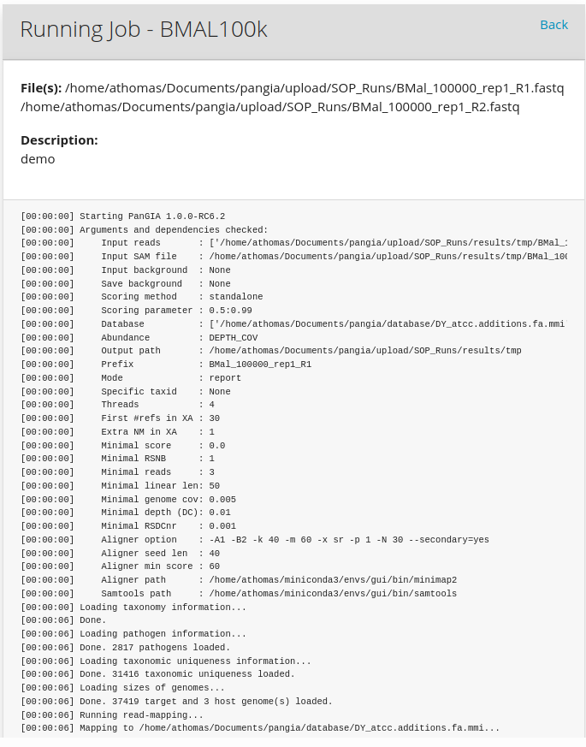

After the job is finished, the **Running Job** page turns into a **Results** page. Job completion will be reflected in the *PanGIA* page of the GUI:

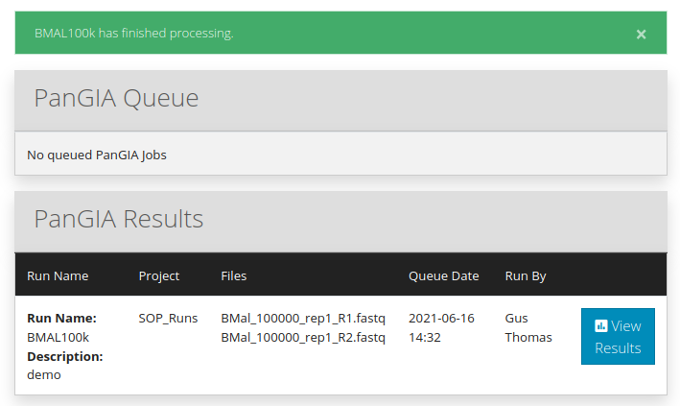The **Results** page should look something like this:

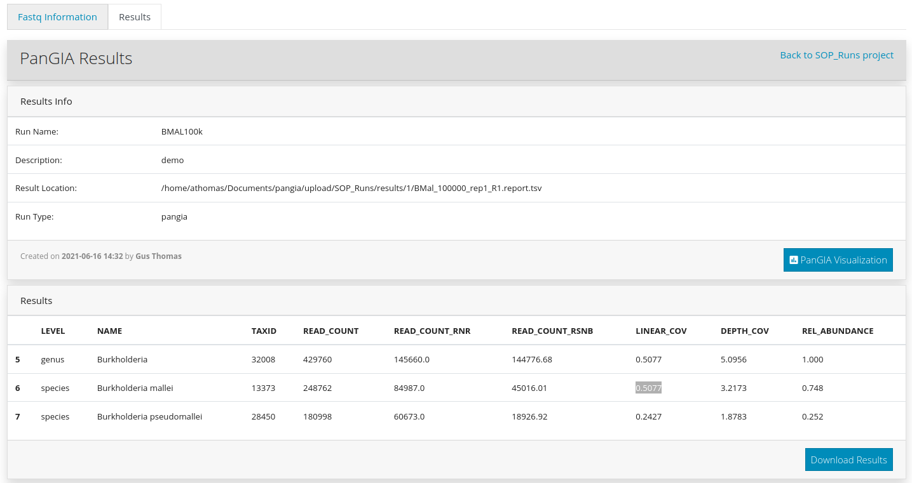

Clicking the **PanGIA Visualization** button opens the **Visualizer** in a separate window. More detail concerning planned features are described in **Section 5**, but the scatterplot for the static PanGIA run as described in this section should appear similar to the one depicted here:

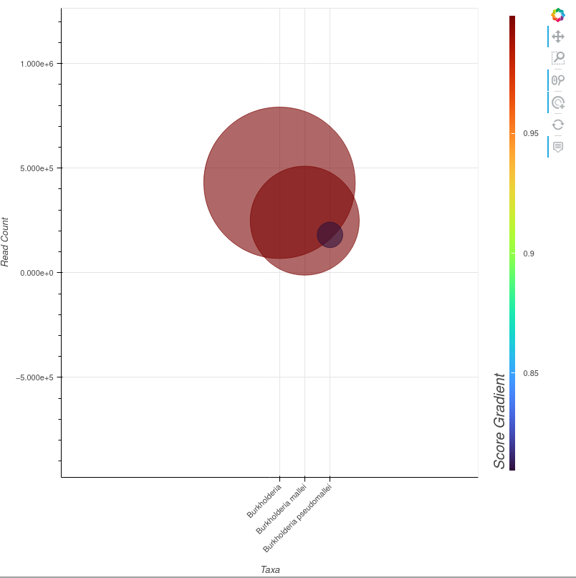

*4.3.1.1*: **Baseline Example Visualizer Usage and Analysis:**

This section discusses current features of the **Visualizer** and uses the PanGIA run described in **Section 4.3.1** to describe how the **Visualizer** is used to interpret PanGIA results. The **Visualizer** displays hits for taxa between the genus and strain level, and includes a scatterplot and datatable. On the scatterplot, each dot on the plot corresponds to one such taxa and are listed on the x-axis.

1. The scatterplot y-axis measures the ‘Raw Read Count’ of each hit. This logarithmic axis is dynamically scaled based on maximum/minimum values present in the sample. In this example, the y-axis covers a very large range of values – between an effective measurement of zero reads and one-million. While this would be too large a scale for comparison of read count between two strain-level hits, it is a very suitable scale in this example, where genus *Burkholderia* is compared against species *Burkholderia mallei* and a further strain subset *Burkholderia pseudomallei*. When interpreting the scatterplot, note that the center of each dot is the point intersecting with the y-axis.
2. The scatterplot color-bar, labeled ‘Score-Gradient’ axis on the right indicates hit performance on the selected ‘Score’ metric – either ‘Standalone’, ‘Background’, or ‘Combined’, as described in **Section 4.2.3.3.** The color-bar is also dynamically scaled; in the above example, strain *Burkholderia pseudomallei* scored lowest among the three hits as indicated by its purplish hue, placing it near the bottom of the color-bar. However, the minimum value for the color-bar is approximately 80%. This result suggests that based on standalone score, PanGIA’s confidence in correctly identifying this strain from the given reads is somewhat lower than it’s confidence in correctly identifying the species or genus the reads belong to – though, the confidence is still quite high. Dynamically scaled axes make comparison between close-scoring hits easier when landscape of hits are restricted to a limited range of scores.
3. The size of each hit on the scatterplot is scaled to its relative abundance in the sample. In this example, reads belonging to genus *Burkholderia* make up a comparatively much larger share than either species or strain.
4. The associated data table for this PanGIA run contains three observations – corresponding to the three data points seen in the above scatterplot. A condensed summary of the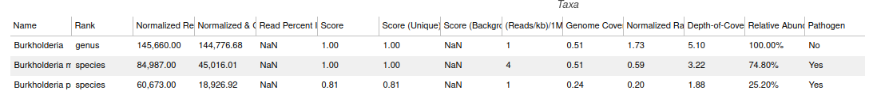 information in a single row of this table appears as a tool-tip when the mouse is hovered over the center of a dot in the scatterplot.
5. The tool-tip presents numerical results from a given row of the data table. In the below image, the tool-tip for *Burkholderia pseudomallei* is shown.

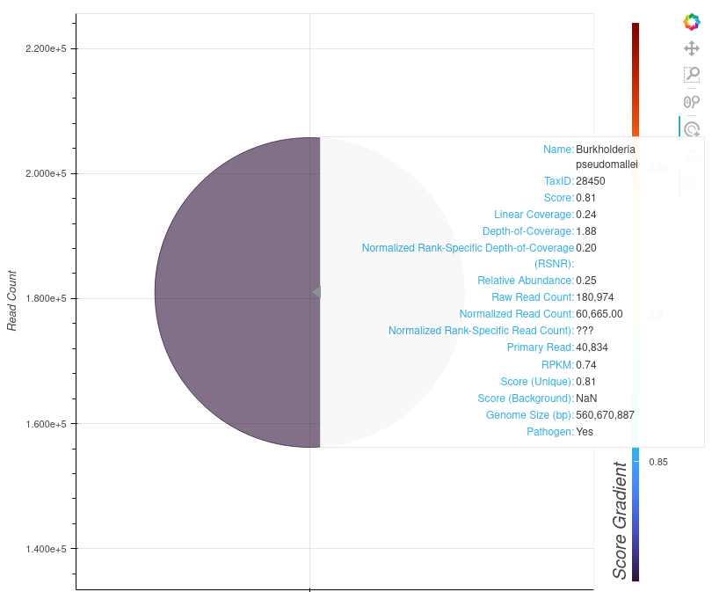

**Section 5): Visualizer Planned Features**

The PanGIA GUI **Visualizer** is not complete. Two main elements – a depth-scale-down chart and sample summary pie-charts – are still in development. In addition, several widgets will be attached to the scatterplot to make it more interactive, dynamic, and powerful. Planned widget features include:

1. Widgets for Numerical Filtering:
   1. Read Count
   2. Linear Coverage
   3. Score
   4. Depth-of-Coverage
   5. Rank-Specific Metrics
2. Widgets for User-Specified Filtering
   1. Returning only specific genus/species/strain, or other ranks based on keywords.
   2. Customization of y-axis/size-axis/color-axis metrics.
3. Widgets for Categorical Filtering:
   1. Pathogenicity Filtering (Yes/No)
   2. Rank Filtering

An example of the **Visualizer** as it will appear with widgets:

